|  |
| --- |
| Chicago Crimes  Team Pandas  UNC Boot Camp July 2019 |
| Divya TV  Harshavardhan Suresh  Kevin Kao  Ramesh Kalagnanam |



## Chicago Crimes

Contents

Chicago Crimes 2

Objectives 3

• Determine crime counts for each month for selected crime types breaking down the timeline for every five years. 3

• Determine relationships between criminal activity and weather conditions. 3

• Determine relationship between popular attractions and criminal activity. 3

• Use google maps to provide details of safe and unsafe places in Chicago for a user specified timeline. 3

Data preparation 3

# Objectives

## Determine crime counts for each month for selected crime types breaking down the timeline for every five years.

## Determine relationships between criminal activity and weather conditions.

## Determine relationship between popular attractions and criminal activity.

## Use google maps to provide details of safe and unsafe places in Chicago for a user specified timeline.

# Data preparation

#### Chicago criminal activity Dataset

##### Dataset

This dataset reflects reported incidents of crime (with the exception of murders where data exists for each victim) that occurred in the City of Chicago from 2001 to present, minus the most recent seven days. Data is extracted from the Chicago Police Department's CLEAR (Citizen Law Enforcement Analysis and Reporting) system.

#### Data description:

Number of records or unique cases:

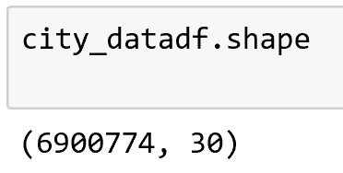

#### Chicago weather conditions Dataset

(Kevin to fill weather dataset details, how he got it, what did he do with it)

#### Use google maps to provide details of safe and unsafe places in Chicago for a user specified timeline.

Safe and Unsafe areas of Chicago based on crime type- Assault between start_date = '07-01-2002'

end_date = '04-01-2019'

